Capstone Project Synopsis
EVision – Smart Charging Forecasting & Location Planner

1. Introduction
The exponential growth of Electric Vehicles (EVs) is transforming urban mobility and accelerating the push toward sustainable transportation. However, this rapid adoption is creating new challenges for cities, energy providers, and EV operators — primarily in predicting future charging demand and optimally locating charging stations.
Current infrastructure often suffers from poor placement, grid overload in high-demand zones, and underutilization in low-demand areas. The lack of integrated, predictive intelligence in infrastructure planning leads to inefficient investments, congestion at charging points, and customer dissatisfaction.
EVision proposes an AI-powered geo-intelligent system that combines time-series forecasting (SARIMA + XGBoost) with geospatial clustering (K-Means on GIS data). This hybrid approach not only forecasts where and when EV charging demand will increase but also identifies and ranks the most suitable locations for new charging stations. An interactive web dashboard will display demand trends, hotspot maps, and site recommendations, empowering urban planners, EV operators, and policymakers to make data-driven infrastructure decisions.

2. Problem Statement
With EV ownership rapidly increasing, existing charging station deployment strategies are struggling to keep up. Current planning approaches rely heavily on:
- Historical usage data without predictive capabilities.
- Manual surveys that are time-consuming and often outdated.
- Siloed datasets that don’t integrate spatial and temporal analysis.
This leads to several operational and economic issues:
- Overloaded grids in certain regions, causing voltage drops and longer charging times.
- Idle or underused charging stations in low-demand areas.
- Poor return on investment for EV infrastructure projects.
Most existing research focuses only on demand forecasting or only on site selection. There is no unified solution that integrates both predictive modeling and geospatial intelligence to recommend where and when to deploy new stations.
EVision aims to fill this gap by developing an integrated forecasting and location-planning platform that provides actionable recommendations, ensuring efficient infrastructure deployment, reduced grid stress, and better user experience.

3. Motivation
The motivation for EVision stems from three converging trends:
- EV Boom & Infrastructure Gap
  - EV adoption rates are accelerating globally and in India, but charging infrastructure growth remains slow and uncoordinated. This mismatch is creating bottlenecks that hinder EV adoption.
- Inefficiencies in Current Planning
  - Poorly placed charging stations result in wasted investments, high operational costs, and inconsistent accessibility for users.
  - City planners and EV operators lack advanced predictive analytics tools for future-proof infrastructure planning.
- Need for Data-Driven Solutions
  - The integration of AI forecasting models with geospatial intelligence can provide a proactive, rather than reactive, planning approach.
  - Such a solution aligns with smart city initiatives, supports green mobility goals, and enables efficient energy distribution by forecasting demand surges before they happen.
EVision is designed to address these challenges by offering a scalable, accurate, and interactive decision-support system that can adapt to changing mobility patterns, technological advancements, and evolving urban landscapes.

4. Our Proposed Solution
The proposed solution is an AI-powered Geo-Intelligent Forecasting and Location Planner designed to address the dual challenge of predicting future EV charging demand and optimally locating new charging stations.
Our approach integrates time-series forecasting models with geospatial clustering techniques to create a unified decision-support platform:
- Demand Forecasting:
  - Use SARIMA to model seasonal and long-term demand patterns.
  - Apply XGBoost to capture non-linear residuals and improve accuracy.
- Spatial Analysis:
  - Employ K-Means clustering on GIS-based features (traffic density, EV ownership distribution, grid capacity) to identify future demand hotspots.
- Recommendation Engine:
  - Score and rank potential sites based on forecasted demand, accessibility, and infrastructure support.
- Visualization & Interaction:
  - Deliver insights via an interactive web dashboard that includes geospatial maps, forecast graphs, and ranked site recommendations.
Key Outcomes:
- Proactive planning of EV charging infrastructure.
- Reduction in grid overload incidents and idle stations.
- Improved ROI for infrastructure investments.
- Alignment with smart city and green mobility goals.

5. Software Requirements
Software / Tool | Purpose
Python | Core programming language for backend and data processing
Flask / JavaScript (React.js / Vanilla JS) | Web backend and interactive dashboard interface
Pandas, NumPy | Data preprocessing, manipulation, and numerical computation
Statsmodels | SARIMA time-series modeling
XGBoost | Non-linear residual learning and improved forecasting
Scikit-learn | Machine learning pipeline and K-Means clustering
GeoPandas / Folium | Spatial data handling, mapping, and GIS analysis
Matplotlib / Plotly | Data visualization, forecast graphs, and trend plots
SQLite | Data storage and retrieval
Power BI | Enhanced geospatial visualization and dashboard analytics

9. Flowchart
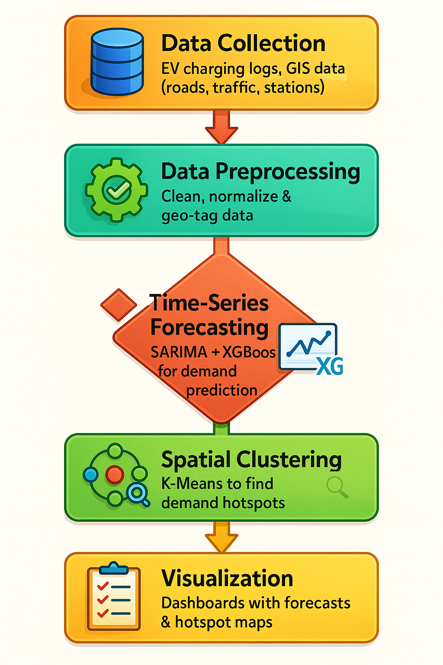

7. Application Usage
- Urban Planning:
Plan strategic EV charging infrastructure deployment in rapidly growing EV regions.
- Smart Cities:
Enable dynamic energy load balancing and integration with renewable energy grids.
- EV Charging Operators:
Improve ROI by targeting high-demand zones and avoiding underutilized stations.
- Fleet & Logistics Management:
Optimize charging schedules and routing for commercial EV fleets.
- Government & Policy Making:
Support green mobility initiatives, carbon reduction targets, and city-wide sustainability goals.

8. Conclusion
EVision presents a comprehensive, AI-driven approach to EV charging infrastructure planning by integrating accurate demand forecasting with geospatial hotspot detection.
Through its hybrid SARIMA + XGBoost forecasting model, K-Means clustering, and interactive dashboard, the system bridges the gap between data analysis and actionable decision-making.
The outcome will be:
- Optimized placement of charging stations.
- Reduced grid stress during peak hours.
- Improved user satisfaction through shorter wait times and better accessibility.
- Higher infrastructure ROI for stakeholders.
By enabling data-driven, predictive, and location-aware planning, EVision aligns with smart city development and accelerates the adoption of sustainable transportation solutions.

